Rubrics for GER225/325-F26 (Intermediate German / Upper level) (MLL updated Guidelines)

Give a short academic presentation (das Kurzreferat) in class on a topic a topic in a German-speaking country
Show (1) sufficient control of frequently used grammatical structures within a variety of
timeframes (present, past, future tenses) and mood references (indicative and subjunctive),
and (2) use pronunciation norms representative of authentic speech.
  - Exceeds: The student can give an oral presentation with little to no reliance on written notes. They demonstrate proper use of vocabulary and idioms within the academic register. There are few to no grammar and pronunciation errors, but they do not interfere with understanding.
  - Meets: The student can give an oral presentation with the occasional guidance of written notes. They demonstrate proper use of vocabulary and idioms within the academic register. There are some grammar and pronunciation errors, but they do not interfere with understanding.
  - Unsatisfactory: The student cannot give an oral presentation without reading from a script. They fail to demonstrate proper use of vocabulary and idioms within the academic register. There are frequent grammar and pronunciation errors that impede understanding.

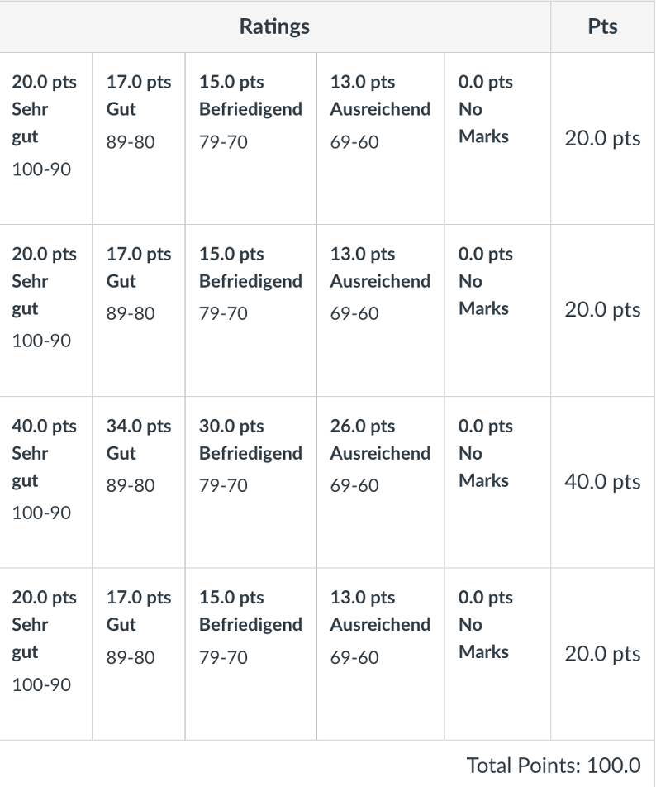

Inhalt termingerecht vorgetragen =
Content delivered on time.

Presentation. Length, Language Use,
Freely spoken, e.g. (exempli gratia) no reading of complete sentences.

Der Wortschatz = vocabulary; Tippfehler = typos;
Wortstellung = syntax;
Zitierte Werke = works cited
(if assigned)

Kreativität und visuelle Hilfen, z.B. Bilder, Tabellen, Charts, …. =
Creativity and visuals, e.g. pictures, tables, charts, …

Name __________________________________________________________________________________________
Name __________________________________________________________________________________________
Name __________________________________________________________________________________________
Name __________________________________________________________________________________________
Name __________________________________________________________________________________________

